Log Analyzer Utility
Overview
Log Analyzer Utility is a Python-based automation tool designed to analyze application log files and generate useful operational insights.
The utility reads application logs, categorizes log entries, extracts error details, and generates reports that can assist support and operations teams in troubleshooting and monitoring activities.

Technologies Used
- Python 3.13
- Git
- GitHub
- CSV

Project Evolution
### Version 1 - Basic Log Analyzer
File: log_analyzer.py
Features:
- Reads application log file
- Counts INFO messages
- Counts WARNING messages
- Counts ERROR messages
- Displays summary report

Screenshot:
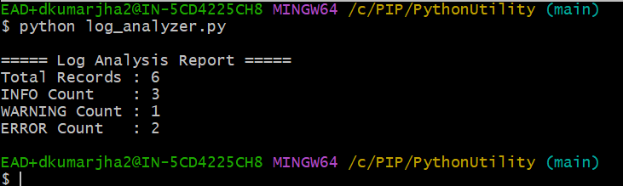

### Version 2 - Enhanced Log Analyzer
File: log_analyzer_upgraded.py
Additional Features:
- Extracts ERROR messages
- Displays detailed error information
- Improves troubleshooting visibility

Screenshot:
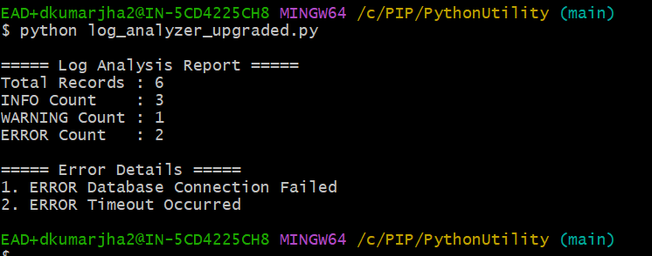
### Version 3 - CSV Report Generator
File: log_analyzer_v3.py
Additional Features:
- Generates CSV report
- Stores analysis results in structured format
- Enables reporting and data sharing
Generated File: log_report.csv
Screenshot of CSV Output:
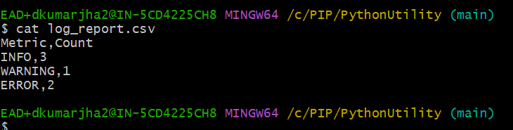
## Repository Structure

PythonUtility/
│
├── application.log
├── log_analyzer.py
├── log_analyzer_upgraded.py
├── log_analyzer_v3.py
├── log_report.csv
└── README.md

## Business Value
- Helps identify application issues quickly
- Provides summarized log analysis
- Reduces manual effort in log review
- Demonstrates automation and scripting capability
- Can be extended for enterprise monitoring solutions

## Future Enhancements
- User-supplied input file
- JSON report generation
- Dashboard reporting
- Email notifications
- AWS deployment

## Author

Deepak Kumar Jha
Analyst II Software Engineering

